**FTP Method**

**Using a z/VM FTP server to receive and load files to a z/VM minidisk (zVM 7.3 Installation Guide.pdf, Appendix K.)**

The following procedure will receive and load the z/VM product DVDs or electronic envelopes to a minidisk on your z/VM system. If loading the files from the electronic envelopes to a directory on your workstation, make a note of the directory path name. Make sure the minidisk where you will load the files is not attached in write mode by any user ID on z/VM. You must have an FTP server running on the z/VM system and a user ID on z/VM that owns an 8000- cylinder minidisk. The minidisk should be formatted with 4K blocks. The user ID should be logged off while you are loading the installation files. To begin open a DOS window on your work station (Like CMD Command Prompt).

**Note**: For this example, the user ID used was JORDAN and the minidisk is 191 and the files were stored on a windows desktop folder named zPROTempBox.  
  
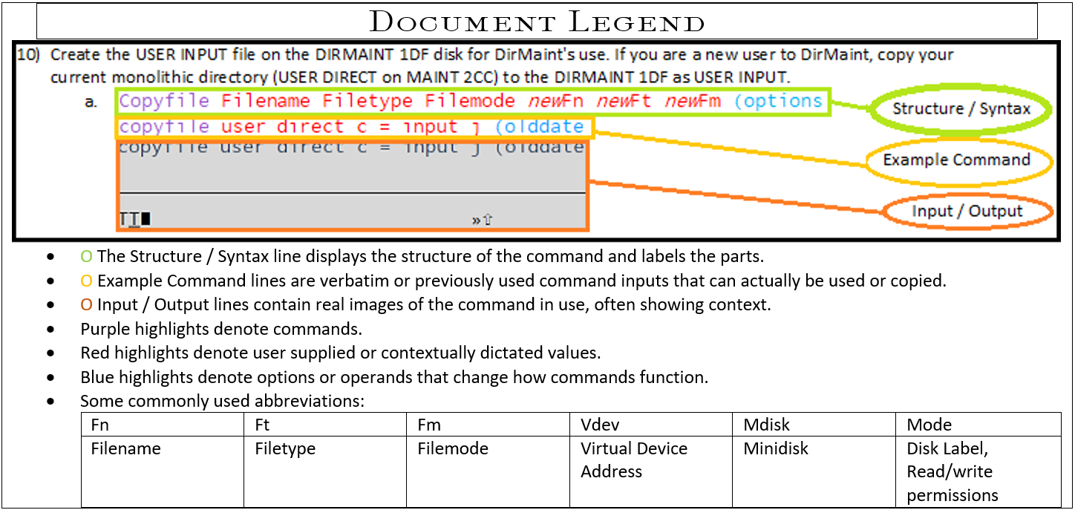

1. Start the FTP session with your z/VM host replacing the x placeholder with the appropriate IP:
   1. ftp *options ipaddress*  
      ftp -i *xx.x.xx.xxx*  
      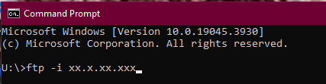
2. Enter the z/VM user ID that can access the minidisk in write mode and the password for that ID:
   1. Username  
      JORDAN  
      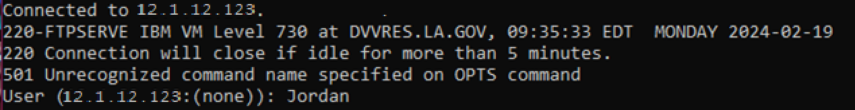
   2. password  
      xxxxxxx  
      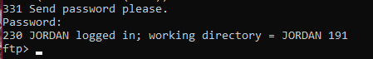
3. Change the working directory on your z/VM host to the minidisk where you want to load the files (note that there is a period between the user ID and minidisk address):
   1. cd zVMdirectorypath  
      cd JORDAN.191  
      
4. Set the Local Directory to the Windows Desktop folder location containing the files you intend to FTP or the destination folder for the files you’re FTPing from zVM.
   1. lcd desktopfolderpath  
      lcd C:\Users\P00341017\Desktop\zPROTempBox  
      
5. Set the file transfer mode to binary (*NOT* a universal rule) and the record format and length to fixed 1028(*CHECK* the logical record length, this changes.):
   1. binary  
      binary  
      
6. Set the file transfer size to 1028 bytes. (Logical Record Length, AKA Lrecl)
   1. quote site fixrec recordlength  
      quote site fixrec 1028  
      
7. Put the installation files on the z/VM minidisk:
   1. mput file  
      mput *.PROD5*  
      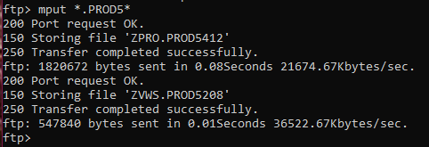
   2. All of the files in the directory that contain, “.PROD5”will now start to transfer. This could take some time, depending on the speed of your connection. For video walkthrough see, “zVM 7.3 FTP” within Reference Materials>Examples>FTP.